作业10：实现一个通知

宗玥 201730145033

2019.11.20

一、作业要求

1.振动模式：震动500ms，停止500ms，震动1000ms

2.弹出横幅

3.显示大图片

二、作业展示

MainActivity完整代码

package com.example.notificationtest;  
  
import android.app.Notification;  
import android.app.NotificationManager;  
import android.app.PendingIntent;  
import android.content.Intent;  
import android.graphics.BitmapFactory;  
import android.graphics.Color;  
import android.os.Bundle;  
import android.view.View;  
import android.widget.Button;  
import androidx.appcompat.app.AppCompatActivity;  
import androidx.core.app.NotificationCompat;  
  
public class MainActivity extends AppCompatActivity implements View.OnClickListener{  
  
 @Override  
 protected void onCreate(Bundle savedInstanceState) {  
 super.onCreate(savedInstanceState);  
 setContentView(R.layout.*activity_main*);  
 Button sendNotice= findViewById(R.id.*send_notice*);  
 sendNotice.setOnClickListener(this);  
 }  
  
 @Override  
 public void onClick(View v) {  
 switch (v.getId()){  
 case R.id.*send_notice*:  
 Intent intent = new Intent(this, NotificationActivity.class);

//点击通知时跳转到页面NotificationActivity  
 PendingIntent pi = PendingIntent.*getActivity*(this, 0, intent, 0);  
 NotificationManager manager= (NotificationManager) getSystemService(*NOTIFICATION_SERVICE*);  
 Notification notification=new NotificationCompat.Builder(this)  
 .setContentTitle("This is content title")  
 .setContentText("this is content text")  
 .setWhen(System.*currentTimeMillis*())  
 .setSmallIcon(R.mipmap.*ic_launcher*)  
 .setLargeIcon(BitmapFactory.*decodeResource*(getResources(),R.mipmap.*ic_launcher*))  
 .setContentIntent(pi)  
 .setAutoCancel(true) //点击通知时通知自动消失  
 .setVibrate(new long[]{0,500,500,1000})

//振动模式：震动500ms，停止500ms，震动1000ms  
 .setLights(Color.*GREEN*,1000,1000) //led灯设置为绿色，亮1s熄1s  
 .setStyle(new NotificationCompat.BigPictureStyle().bigPicture(BitmapFactory.*decodeResource*(getResources(), R.drawable.*study1*))) //设置大图显示  
 .build();  
 manager.notify(1,notification);  
 break;  
 default:  
 break;  
  
 }  
 }  
  
}

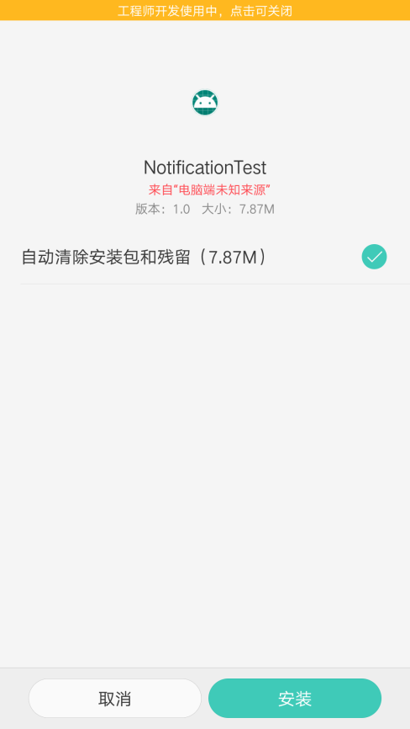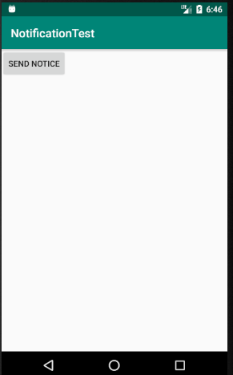 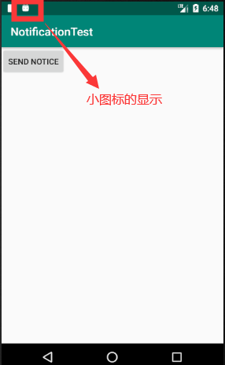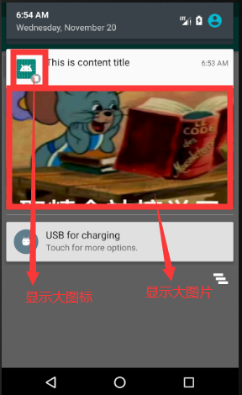

用手机进行调试，震动500ms后静止500ms再震动1000ms

setVibrate(new long[]{0,500,500,1000})